Abram Denzlinger

February 8, 2026

5.2 - bioSite Ideas, Sketches, and Inspiration

Front-end Style Guide (color palette)

| **Color** | **Hex Code** | **Role** |
| --- | --- | --- |
| **Writer’s Ink** | #4A0E0E | Primary / Headings |
| **Blueprint Grey** | #2C3E50 | Secondary / Nav |
| **Manila Archive** | #FDF5E6 | Background |
| **Cement** | #BDC3C7 | Accents / Rules |

Wireframes

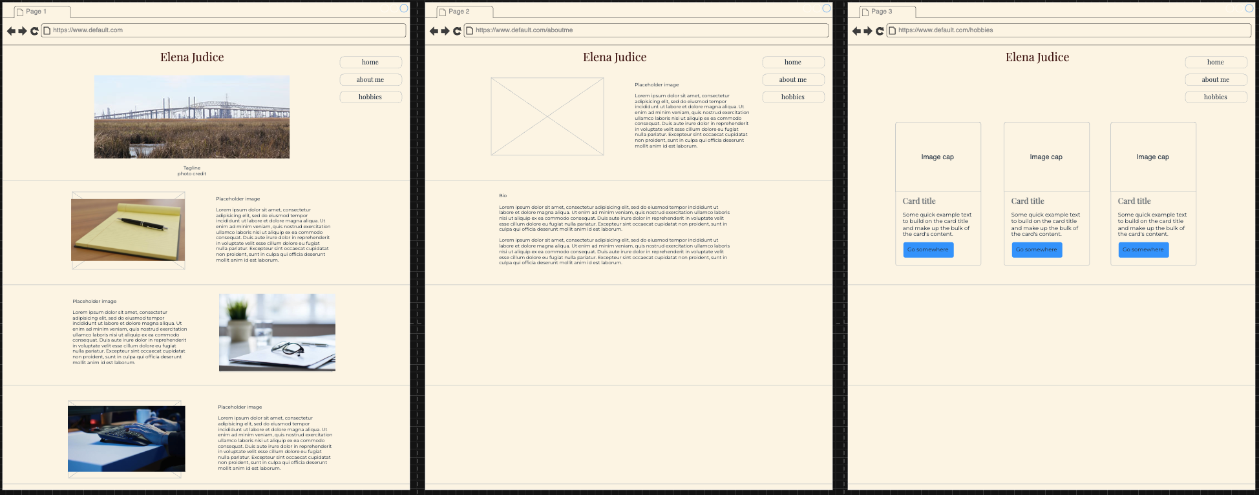

Interview

1. **How would you describe yourself to a total stranger in three sentences?** "I’m often described as a ‘firecracker’—which is usually code for being unapologetically passionate and loyal to a fault. I am fiercely independent, though that hardness is balanced by a deep, quiet love for my family. I am ultimately defined by the work I do and the people I protect."
2. **Where did you grow up, and how did that environment shape you?** "I was raised among the salt marshes of Southeast Texas, right on the Gulf where the horizon is a blur of water and industry. Growing up in a blue-collar, union-driven household instilled a relentless work ethic and a desperate hunger to transcend my circumstances. Books were my initial escape, but writing became the mechanism through which I processed trauma and began to blueprint a different life."
3. **What is a piece of advice or a 'mantra' you live by?** "‘Done is better than perfect.’ For a perfectionist, an unfinished project is just a slow-motion failure sitting in a drawer. I’ve learned that the world has no use for a masterpiece that doesn't exist; you have to ship the work, flaws and all. You can’t edit a blank page."
4. **What is a 'hidden talent' or a quirky fact about you?** “People familiar with my enthusiasm (obsession?) for literature may be surprised to learn that I’m an expert with a handgun and with a rod and reel. It’s not as contradictory as it may sound - there is a specific kind of quietude found in a library and a shooting range. Both require a calibrated focus and a respect for the mechanics of the tool in your hand."
5. **How did you first get started with writing, and what was that 'spark' moment?** "Academic writing always felt like a native tongue to me. The 'spark' was actually more of a wildfire: I was placed in AP English, but the volatility of my home life at the time made the workload impossible to sustain. Dropping back to a regular class wasn't a failure of talent, but a survival tactic. It taught me early on that writing requires more than just 'gift'—it requires stability and grit."
6. **When you’re deep into writing, what does your 'flow state' feel like?** "The periphery simply dissolves. The domestic noise—the laundry, the emails, the rhythmic hum of the refrigerator—recedes into the background. My brain finally stops 'managing' the logistics of life and begins the pure act of 'being.' It is a paradox: an experience that is simultaneously silent and deafeningly loud."
7. **What is the most challenging thing about writing, and how do you push through?** "Temporal poverty. Between professional deadlines and the demands of a household, two hours of silence is a rare currency. I’ve adapted through 'micro-writing'—dictating voice memos during my commute or drafting paragraphs in my phone’s notes app between commitments. I’ve learned to write in the gaps."
8. **What 'tools of the trade' are essential to your hobby?** "My setup is a mix of the analog and the high-tech: grocery-store reading glasses, a standard legal pad, a fresh box of pens, a mechanical keyboard with the right tactile 'click,' a large monitor for deep focus, and noise-canceling headphones to gatekeep my attention."
9. **If you could look five years into the future, what is one big goal you hope to have checked off?** "Right now I’m tinkering with a new book review platform that moves beyond the reductive 'five-star' system. I want to build something that offers nuance—matching books to readers based on demographics, reading volume, reading habits, reading proficiency, motivation, interests, and 'perspective-shifting' recommendations. In five years, I hope to have cultivated a community of readers who value insight over mere ratings."
10. **Can you describe a specific 'turning point' in your life?** "Leaving my role as a Marketing Director for a defense contractor. Shifting into Technical Writing for a medical devices firm was a moral recalibration. It was the moment I stopped using my words to sell an industry I didn't believe in and started using them to provide clarity in a field that actually saves lives. My career and my principles finally became aligned."

Bio

Elena Judice is a study in contradictions. If you met her at her day job as a technical writer for a medical device firm, you’d see a professional defined by meticulous detail and a sharp, logical mind. But Elena is far more than the manuals she crafts. Born and raised among the salt marshes of Southeast Texas, her roots are firmly planted in a blue-collar, union-driven world that taught her the value of a hard day's work and the grit required to change one’s circumstances.

A self-described "firecracker," Elena navigates life with a fierce independence and a loyalty that is second to none. While she spent her youth using books as an escape from a turbulent home life, she eventually turned that love of language into a career. She’s the kind of person who can quote Hemingway or Steinbeck by heart, yet is just as comfortable in the mud of the Texas Gulf Coast. Whether casting a line with a rod and reel or practicing her focus at the shooting range, Elena finds a unique kind of peace in the mechanics of a tool and in the silence after a well-aimed shot.

As a single mother of two, Elena’s life is a constant balancing act between professional deadlines and domestic chaos. A major turning point came when she walked away from a high-pressure marketing director role to find a career that actually aligned with her values. Today, she is architecting a future that includes a more nuanced way for readers to discover books, proving that you don't have to choose between being a "creative" and a "professional." For Elena, the goal is simple: keep moving, keep writing, and remember that "done is better than perfect."

Images

1. Embellishment - Southeast Texas marshland, with refineries in the background

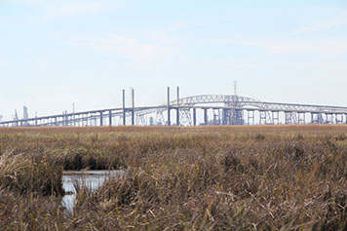

1. Embellishment - Markswoman

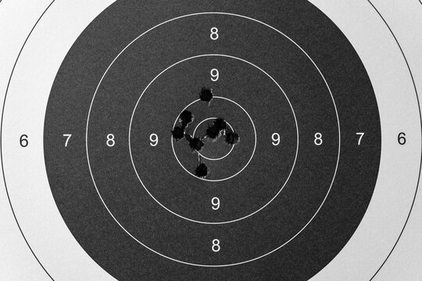

1. Accomplishments - Career - Technical Writer



1. Hobby - Literature

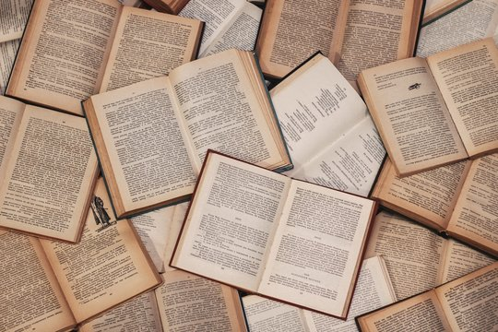

1. Hobby - Book Reviews



1. Hobby - Toy Australian Shephards

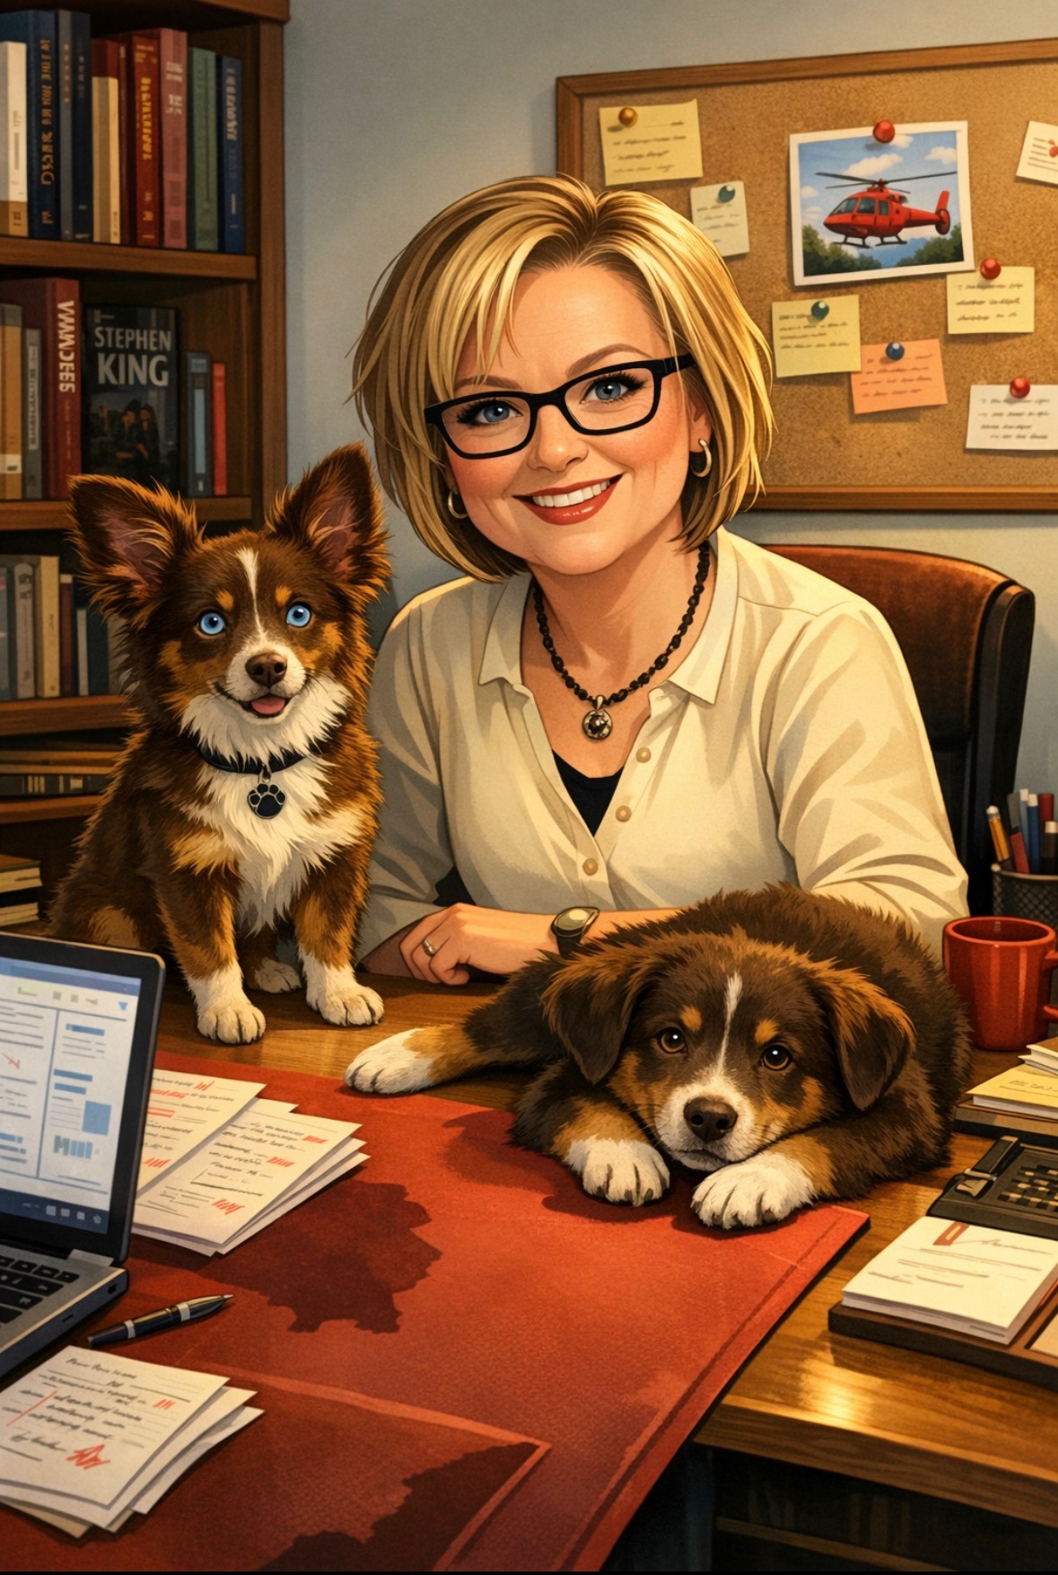

1. Portrait

